Room Allocation Database Requirements

Version 1 - January 24, 2023

**Requirements Document**

**Slippery Rock University**

**Room Allocation**

VERSION: 1.0 REVISION DATE: January 24, 2023

**Team Members**

|  |
| --- |
| **Name** |
| Jinish Patel |
| Ian Phelps |
| Samantha Stapf |
| Isaac Valasek |

**Approver – Dr. Sam Thangiah**

# Section 1 Purpose

The purpose of this program is to provide a database of all the classrooms that are available at Slippery Rock University. It will be used to help professors select a room based on the needs of the course they are teaching. It could also be used to allocate a room to outside groups, such as a club. Each room will have a picture along with a description of its location, condition, and features. A few of the features may include the number of seats, the type of projector, and if there are computers available to the students. The professors can use a filter feature to find a specific room that fits their classroom requirements. They also have the ability to print a report of the features of a certain room.

# Section 2 General System Requirements

For the Room Allocation System, we would need to develop a system that can keep track of what rooms are allocated for events. To do this, the system would need several tables that would contain the data such as what rooms can and cannot be rented out, whether those rooms are in proper condition to allocate, whether said rooms can be used for nonrecreational activities, as well as preventing any overlap of room rentals by keeping track of the allocation. This system would have to be available 24 hours a day so that rentals could be made at any time. This system would also have to be accessible over the internet, so that room allocations can be made from anywhere on campus.

For the Room Allocation System, we would need a few conditions for it to work. First, we would need a login page for the system so only trusted SRU users could access it. Ideally this would involve logging in with their SRU email and password. Secondly, this system would utilize MySQL. This system would need to keep track of various pieces of information such as rooms, their states, prior allocations, etc. For this, we would need a database manager to keep track of this data.

For the Room Allocation System, we would need to create a proper User interface that would allow for people to easily schedule events in rooms. This user interface would have to list all rooms that can be allocated out. These rooms could be filtered out based on condition, availability, and whether the room can be used for nonrecreational activities. The UI would also have to be limited to a single page for simplicity's sake.

# Section 3 System User Characteristics

For the Room Allocation System, the users would be divided into various categories:

* Function
  + User (Read-Only Access) - Users will be able to read the data without any other access
  + User (Read/Write Access) - User will be able to read, update, search the data
  + Admin: Would oversee and grant requests for allocation as well as managing update, entry, retrieval, and deletion of data
* Location
  + Users would be able to access program from anywhere
* Devices
  + Laptops/Computers

**Section 4 Hardware and Software**

* Computer with SRU Domain access
* MySQL/Other Database Management System
* Jasper Report
* Java Eclipse
* SpringBoot
* Maven
* Excel
* Web Browser

**Section 5 Database Schema**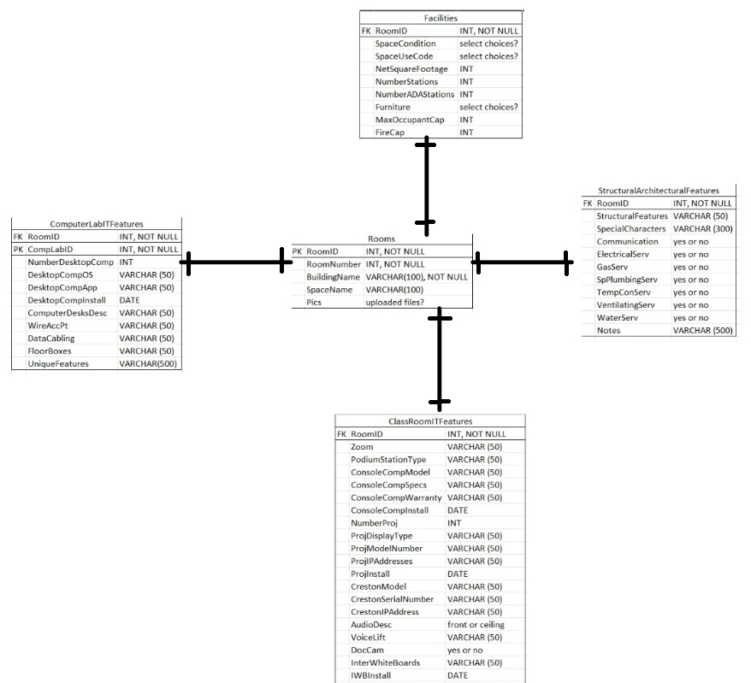

**-** A log table to log all the changes – column ModUser, ModDate, CreateBy, CreateDate

**-** Incorporate non-academic event room list into current database schema

**Section 6 Application Workflow**

* Users will sign in using their SRU email address. Depending on user permissions, users will be able to see tabs
* Admins
  + Manage users – admin will be able to add and remove users
  + DataGrid tab – admin will be able to update, delete, retrieve, entry, and search the entries
  + Database form tab – will be able to see the datagrid
* User – Read/Write
  + DataGrid tab – will be able to enter data, retrieve data, and search data. Will not be able to update or delete
  + Database form tab
* User – read-only
  + DataGrid tab – will only be able to see the data
* Forms for the rooms will be in the database tab. User with appropriate permissions can access the tab and update or enter data. Once data is entered, save button is clicked and this will update the results in backend database management system
* DataGrid tab will be available to users with appropriate permissions. Users with admin privileges will be able to see the datagrid, double click rows to access the forms and edit if necessary. Datagrid will also show a locked icon and a delete symbol to represent whether forms are locked. Delete icon will be displayed for admins only if they choose to delete entries
  + Users with read/write will also be able to do the same with the exception of delete. Users will be able to lock the forms, once locked, only admins are able to access the forms
  + Users with read-only permissions will be able to double click the rows and will show them the entire form in read-only manner where users will not be able to update, delete entries. These users will also be able to use datagrid search functionality
* Users will be able to download reporting files for datagrid vs. room they select

**Section 7 Testing and Deployment**

* Extensive internal and external testing
* System needs to be have SSl capabilities to be deployed to an external server and tested to ensure it works without any errors.
* Deployment to web server after extensive UAT testing